2026 Fall Leadership Conference Advisor Packet
November 16 and 17 2026 | Hilton Baton Rouge Capitol Center
October 1, 2026
Dear SkillsUSA Advisors, Sponsors, and Prospective Advisors,
SkillsUSA Louisiana invites chapter officers, student leaders, advisors, and prospective chapters to the 2026 Fall Leadership Conference in Baton Rouge. The conference will provide practical leadership training that students can use to strengthen their local chapters and serve their schools.
Please register participants by November 6, reserve hotel rooms by November 3, and review the enclosed registration, payment, supervision, and medical-release requirements. We look forward to helping your students build stronger leadership skills and return home prepared to lead.

Advisor Action Checklist
Required Actions
By November 3 | Reserve rooms at the Hilton Baton Rouge Capitol Center using the SkillsUSA Louisiana group rate.
By November 6 | Register all students, advisors, nonmembers, and design contestants at www.skillsusa-register.org.
Before arrival | Collect signed liability and medical release forms for every attendee and provide students with the current Code of Conduct.
Before arrival | Submit payment, an approved school purchase order, or bring payment to registration on Monday.
Before arrival | Give Statesman Award participants the current study guide and conference instructions.

Conference Summary
Conference dates | Monday, November 16 through Tuesday, November 17, 2026
Location | Hilton Baton Rouge Capitol Center, 201 Lafayette Street, Baton Rouge, LA 70801
Registration | $100 per participant; due November 6; $10 late fee per registrant
Hotel | $139 per room, per night, plus applicable taxes and fees; reserve by November 3

Conference Details and Condensed Agenda

Registration and Meals
The $100 registration fee includes Monday lunch, Monday dinner, conference sessions, materials, and scheduled evening activities. Tuesday meals are not included; each school is responsible for its own arrangements.
Registration packets may be picked up outside the Riverview Room between 9:00 to 10:30 a.m. Monday. Students should be checked in and seated before the 10:30 a.m. opening session.

Monday November 16, 2026
Monday Schedule
9:00 a.m. | Conference registration opens at the Hilton
10:30 a.m. | Opening session
11:30 a.m. | Lunch
12:30 p.m. | Leadership sessions resume
4:00 p.m. | Afternoon sessions conclude and hotel check-in period begins
7:00 p.m. | Dinner and evening activities at the hotel
11:00 p.m. | Student curfew

Tuesday November 17, 2026
Tuesday Schedule
Before 8:30 a.m. | Breakfast on your own and turn in completed Statesman Award sheets
8:30 a.m. | General session, awards, and closing session
By 12:00 p.m. | Conference dismissal and safe travels

Advisor Supervision and Conduct
- Advisors are responsible for their students throughout the conference.
- All participants are expected to attend scheduled activities and represent SkillsUSA positively.
- Students may leave a scheduled activity only with advisor approval and supervision.
- Advisors should monitor curfew and all hotel conduct expectations.
- No refunds will be issued after registration is submitted.

Registration and Payment Summary
Return this page with payment or an approved purchase order
SkillsUSA chapter or school | ____________________________________________________________
Lead advisor | ____________________________________________________________
Advisor email | ____________________________________________________________
Advisor phone | ____________________________________________________________

Online Registration Required
All participants and design contestants must be registered through the national registration system:
https://www.skillsusa-register.org
Registration must be submitted by November 6, 2026. A $10 late fee will be added for each late registrant. Payment is requested before the conference; an approved school purchase order or check may be presented at Monday registration if advance payment is not possible.

Design Contests
- Pin, T-shirt, and banner design contest fee: $10 per design contestant; submit two sets of each design and follow the applicable National Technical Standards.
- Register competing students as “Design Contestant/Conference Participant”, not only as “Conference Participant”.
- All submitted designs become the property of SkillsUSA Louisiana once entered.

Amount Due
Item | Quantity | Rate | Amount
Conference participants | _______ | $100 | $__________
Design contestants | _______ | $10 | $__________
Total due |  |  | $__________

Mailing Instructions
Make checks payable to SkillsUSA Louisiana. Mail payment, this summary page, and the submitted online registration invoice to SkillsUSA Louisiana, Fall Leadership Registration, 498 Enterprise Dr., Houma, LA 70360.

Online Registration Instructions
Register conference participants through the SkillsUSA registration system. The menu names below may vary slightly if the system is updated.
https://www.skillsusa-register.org

Add or Update Members
- Select Membership from the main menu, then select Add/Edit Members.
- Review the advisors listed for your school and update them if needed.
- Select the appropriate advisor and open the member list.
- Use New to add a student or member who is not already listed.

Register Participants
- Select Conference Registration from the main menu.
- Choose SkillsUSA Louisiana Fall Leadership Conference.
- Select Add Registrant and choose the correct registration type.
- Select an existing member from the list or enter the registrant information manually.
- Complete all required registrant details and save the registration.
- For a pin, T-shirt, or banner contestant, select Design Contestant/Conference Participant and add the contest only under that contestant’s name.
- Non-advisors and nonmembers may also be registered through the conference registration screen.

Submit Registration and Payment
- Return to Conference Registration and select Submit Registration.
- Enter the school check number or purchase order number.
- Print the Event Fee Details or registration invoice.
- Send the invoice, registration summary, and payment or purchase order to SkillsUSA Louisiana.

Registration Assistance
For assistance, contact Jeremy Boudreaux at (985) 257-7545 or Jeremy@skillsusala.org.

Personal Liability and Medical Release
Required for every conference participant
SkillsUSA Louisiana, Inc. is referred to below as SkillsUSA Louisiana. Please print clearly. A parent or guardian must sign for every participant under age 18.
Participant Information
Participant name | ____________________________________________________________
School or campus | ____________________________________________________________
Type and age | [ ] Student [ ] Advisor [ ] Other [ ] Under 18 [ ] Age 18 or older
Participant phone | __________________________
Emergency contact | ____________________________________________________________
Emergency phone | __________________________
Allergies or medical needs | ____________________________________________________________  ____________________________________________________________
I release SkillsUSA Louisiana, its representatives, agents, employees, and assistants from liability for injury to the participant named above arising while attending or traveling to or from the SkillsUSA Louisiana Fall Leadership Conference in Baton Rouge, Louisiana, except for injury or damage resulting from willful acts.
I authorize SkillsUSA Louisiana or its representatives to secure emergency assistance and medical evaluation or treatment when considered necessary. I agree to indemnify and hold harmless SkillsUSA Louisiana and its medical-services coordinators, assistants, or designees from claims arising from treatment rendered in good faith and according to accepted medical standards.
I have reviewed and agree to the SkillsUSA Personal Liability and Medical Release, Conference Code of Conduct, and Photography and Sound Release on the following page. I agree to follow all conference procedures, conduct expectations, and advisor instructions.
Parent or guardian signature for participants under 18 | Date
Participant signature | Date
Important: Schools should follow their own policies for safeguarding medical information and retaining signed forms.

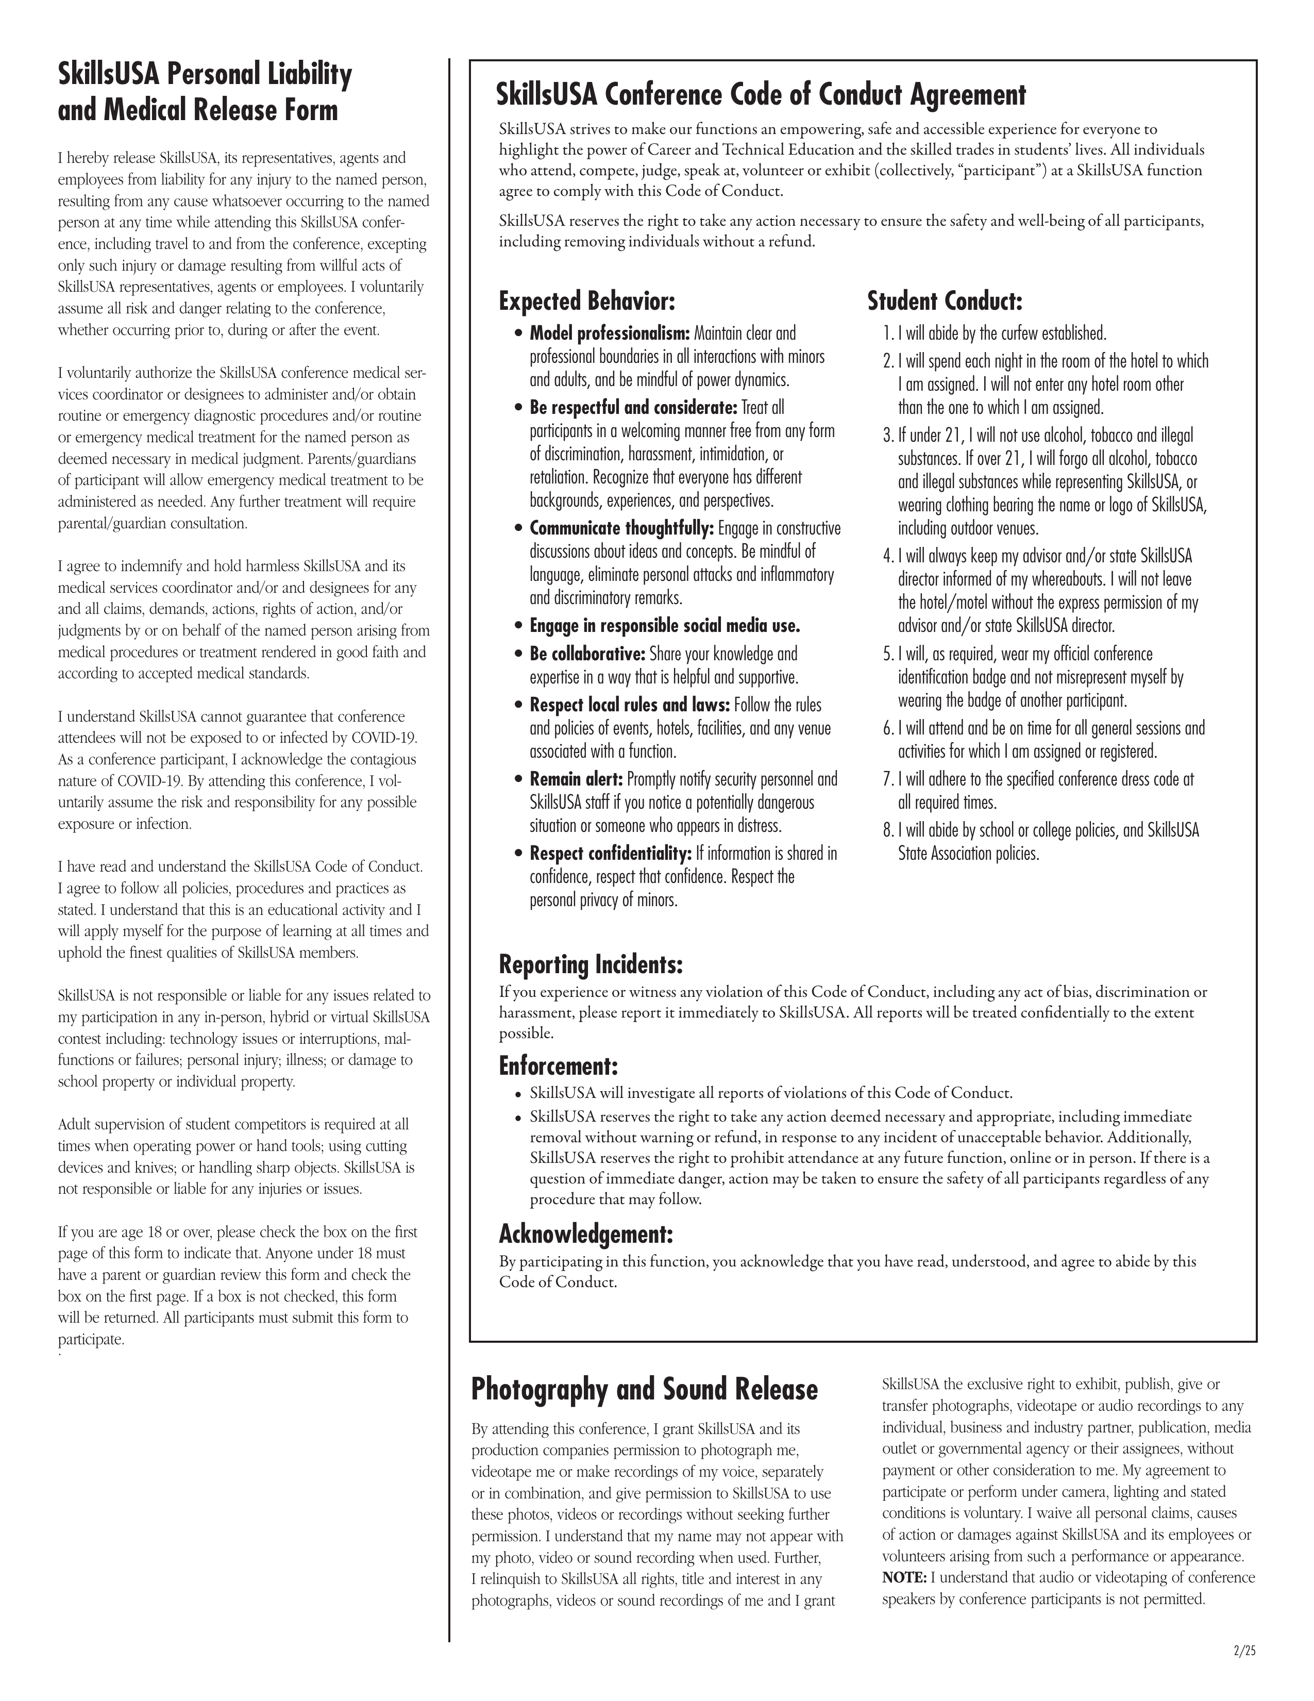

SkillsUSA Louisiana Statesman Award
Fall Leadership Conference | November 16 and 17 2026
Conference participants, including students and advisors, may earn the SkillsUSA Louisiana Statesman Award during Fall Leadership Conference in Baton Rouge.
To earn the award, participants must study the current SkillsUSA facts, program information, and SkillsUSA Framework material provided in the Louisiana Statesman Award study guide. Each participant will receive an official check-off sheet at conference registration.
Participants should be prepared to answer the required questions for designated national officers, state officers, or advisors. The designated reviewer will initial each completed item on the official check-off sheet.

Completion Deadline
All completed Statesman Award check-off sheets must be turned in by 8:30 a.m. Tuesday, November 17, 2026.

Advisor Responsibilities
- Give participating students access to the current Statesman Award study guide before the conference.
- Encourage students to begin studying as soon as they receive the conference packet.
- Participate alongside students when possible and model the value of professional growth.
- Confirm that completed official check-off sheets are submitted by the deadline.

Study Materials
The current study guide and supporting materials should be downloaded from the SkillsUSA Louisiana website before the conference:
https://skillsusala.org

Hotel Reservations and Tax Guidance

Hilton Baton Rouge Capitol Center
Address | 201 Lafayette Street, Baton Rouge, LA 70801
Group rate | $139 per room, per night, plus applicable taxes and fees
Reservation deadline | November 3, 2026
Check-in | 4:00 p.m.
Checkout | 12:00 noon
Reservation phone | 1-800-955-6962
Group name | SkillsUSA LA Fall Leadership

Online Hotel Reservation Link
To be Provided at a later date.
Each school is responsible for making and confirming its own hotel reservations. Schools should retain a rooming list for their records and follow district lodging and supervision policies.

Louisiana Government Travel Tax Exemption
Louisiana Form R-1376 is intended only for eligible employees of the United States government, the State of Louisiana, and Louisiana political subdivisions whose authorized travel expenses meet the form requirements. It does not automatically apply to every student or every hotel room in a school group.
Eligible advisors or governmental employees should use the current R-1376 form and provide any supporting documentation required by their employer or the hotel. Confirm eligibility and billing arrangements with the school system and hotel before arrival.
Current Louisiana R-1376 form and instructions

